AP Calc Roller Coaster Project Name: ________

Concept: Continuous piecewise functions

Consider the piecewise functions $f\left(x\right)=\left\{\begin{matrix}\begin{matrix}-3-x, & x<-3\end{matrix} \\ \begin{matrix}x^{2}-9, & x≥-3 \end{matrix}\end{matrix}\right.$

Prove that this function is continuous at x = -3

Now consider the piecewise function $f\left(x\right)=\left\{\begin{matrix}\begin{matrix}kx-3, & x<1\end{matrix} \\ \begin{matrix}{-x}^{2}+3x+5, & x≥1 \end{matrix}\end{matrix}\right.$

State the value of k to make this function continuous.

Did you get k = 10

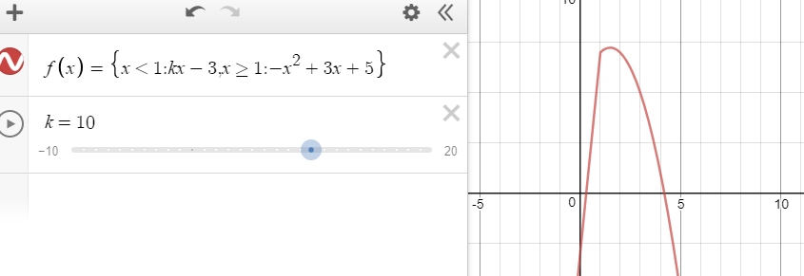

You get the idea of “making a piecewise function continuous”

Project: Design a roller coaster piecewise function with animation in desmos.com

Requirement: The wagon starts from ground, goes up then starts to fall. At least 1 big fall and 1 small fall (make sure your wagon have enough potential energy to complete its route). Underground and/or 360o loop is a plus.